Media release to Sunningwell Town Council
Clerk Kate Bennett
clerk@sunningwell-pc.gov.uk



Hi Kate,
The Vale Path Volunteers (VPV), the path maintenance group of Vale of White Horse Ramblers, recently cut back 450 metres of overhanging vegetation from the bridleway called Penn Lane, which connects north Abingdon to Sunningwell. This was the first time that we had used our new battery-powered, high-reach hedge trimmer. We had purchased this with an £800 grant from Trust for Oxfordshire’s Environment (TOE).
VPV leader Pat Rosum described the issue “Overhanging branches and brambles had become a significant obstacle for horse riders and made the route virtually impassable. Our new tool proved invaluable, enabling us to efficiently remove these high-level obstructions from the safety of ground level.”
Encroachment of brambles and other dense vegetation from the sides of the bridleway also made life difficult for walkers, wheelers and cyclists. The new hedge trimmer, in combination with our existing standard battery-powered hedge trimmer— also purchased with a grant from TOE - formed an effective combination for dealing with the issue.
“This partnership of tools allowed the VPV to clear the bridleway swiftly and thoroughly”, said Pat, “dramatically improving the route much more quickly than if we had only used hand tools.” Pat added “This substantial effort ensured that the entire route is now far more inviting and navigable for all users.”
Ben Heaven-Taylor, CEO of Trust for Oxfordshire’s Environment, said “TOE aims to connect people to nature in their everyday lives. This focus is strongly supported by the work of the Vale Path Volunteers. By equipping them with specialist tools, they are able to clear pathways across the countryside safely and efficiently. This is an excellent use of grant funding, as it not only enhances their capacity but also ensures that more people can access and engage with nature, keeping our countryside paths open and accessible for all.”
ENDS
Photos below and attached to the email.
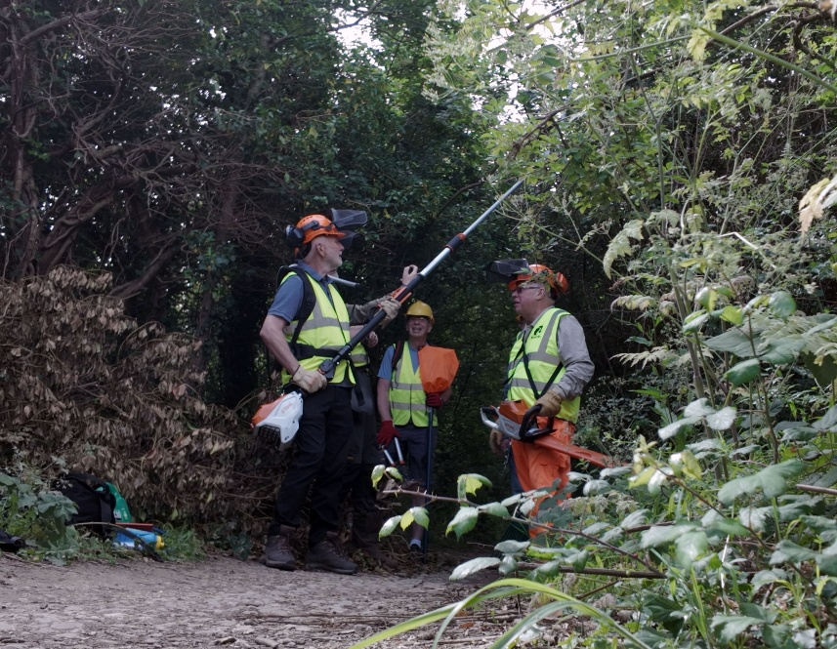
(Above) Left, Andy with the new battery-powered, high-reach hedge trimmer and, right, the shorter hedge trimmer.
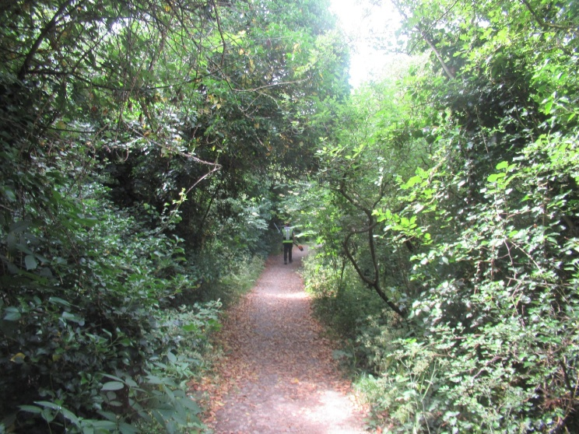
An example of the overgrowth from the top and sides of the bridleway Penn Lane.

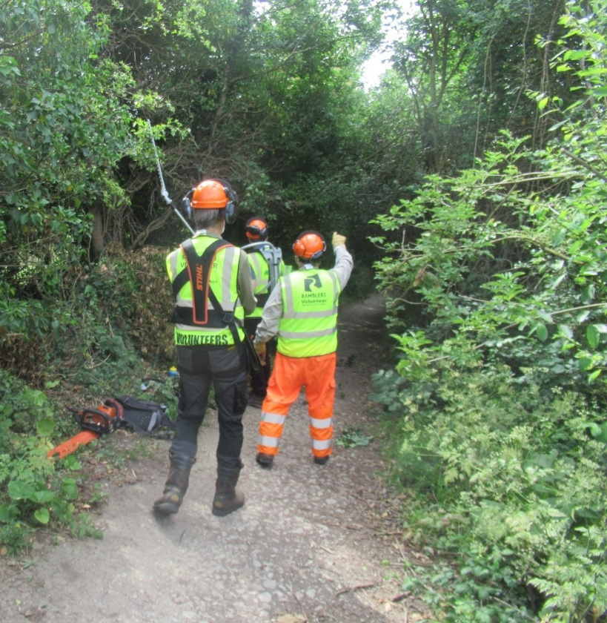
Pat pointing out one of the issues ahead.

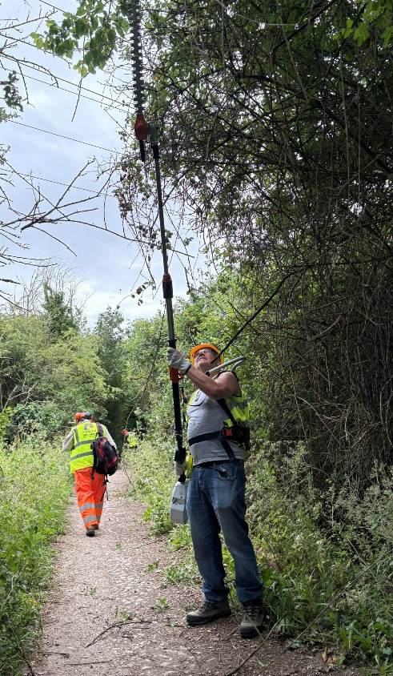
Trevor, showing the high reach of the new hedge trimmer, excellent for removing vegetation that would be in the way of horse riders and cyclists.

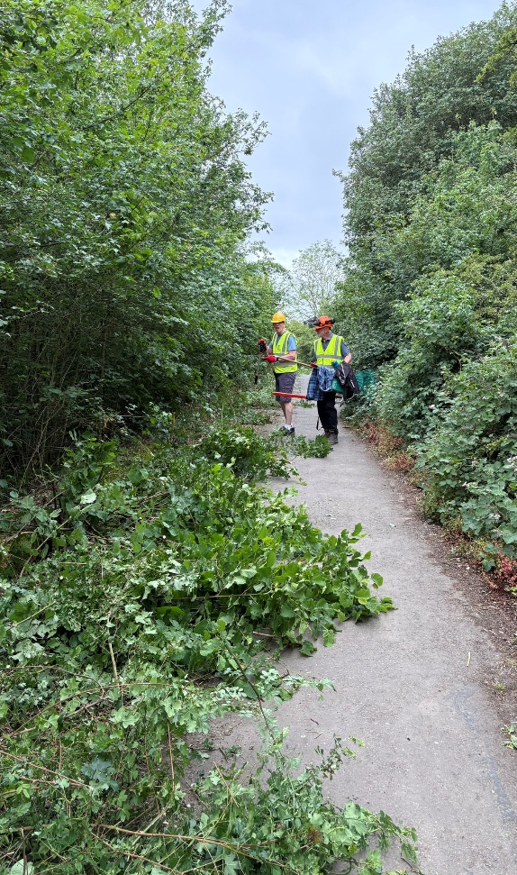
Showing the much-improved width of this section of the bridleway.

